Skill 9

- To Change Directories, Validate Paths, Update Working Directory, Handle Errors, Maintain Previous Directory, Test Navigation.

Code:-
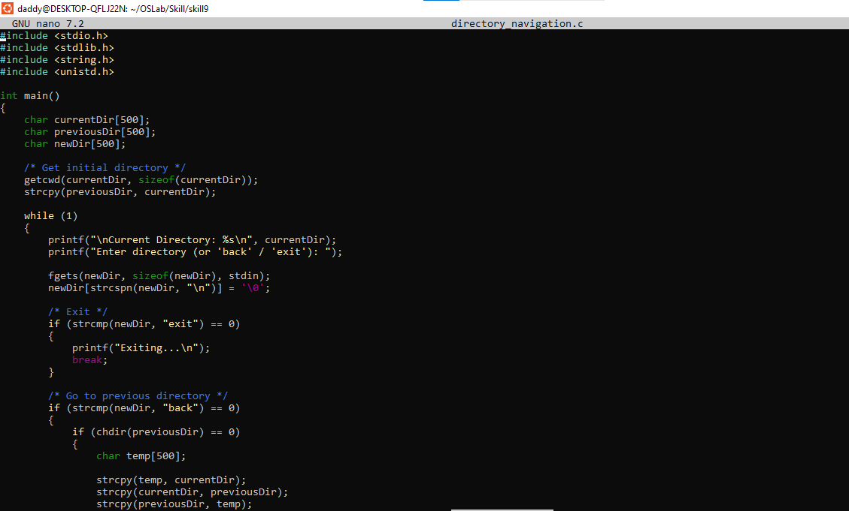

Output
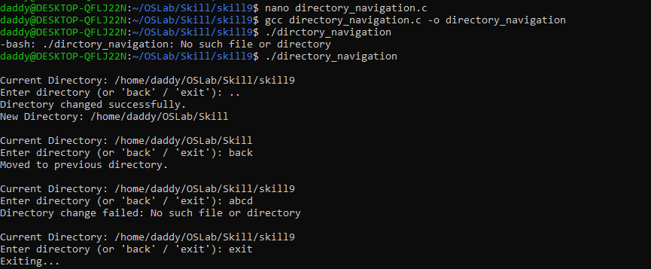

To Identify Built-ins, Create Dispatch Table, Execute In-Process Commands, Handle Invalid Commands, Maintain State, Test Dispatch Logic

Code
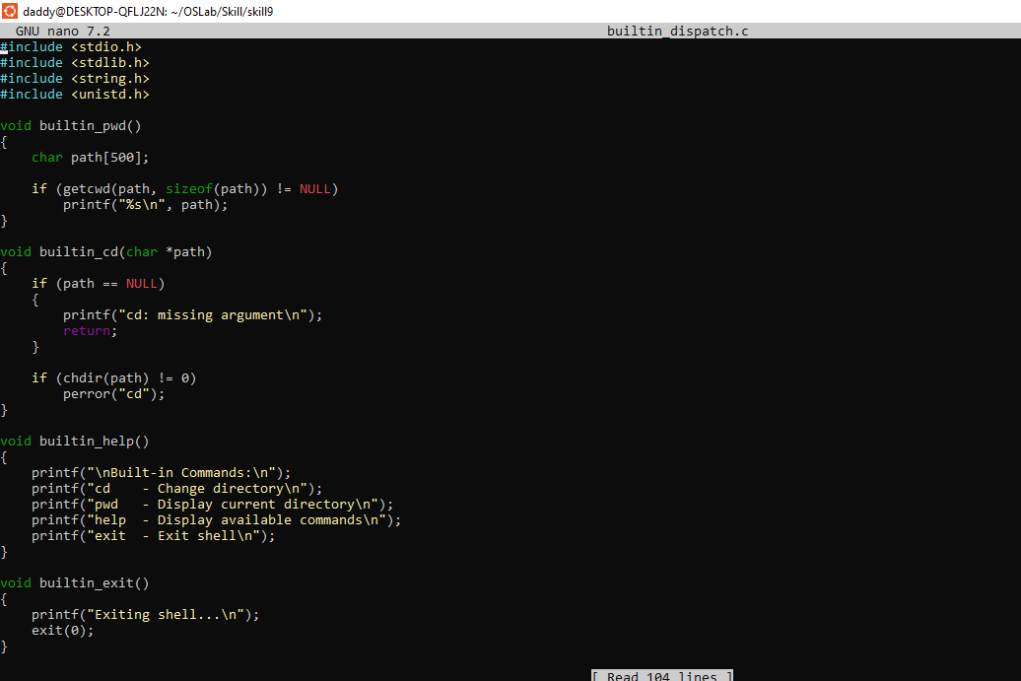
Output
